All User Story

1. Movie Title - Text

* As a user I want to see the list of movie title so that I know the available movie name. (RM)
* As a user I want to add movie name so that new movies can be shown on the list. (C)
* As a user I want to edit any movie title so that I can correct any mistakes. (U)
* As a user I want to view the title of movie individually. (RS)
* As a user I want to delete any movie title from the list so that I can remove any movie title from the list, if necessary. (D)

1. Movie Release : Date

* As a user I want to add movie release date so that anyone can visit to see the list of all movie release date.
* I want to edit any release date of movie. (U)
* As a user I want to view the release date of movie individually. (RS)
* I want to delete any movie release date. (D)

1. Summary of University: Text area

* As a user I want to see the list of summary of university so that anyone can view the university’s summary. (RM)
* As a user I want to add summary. (C)
* As a user I want to view the summary of individually. (RS)
* As a user I want to edit any summary so that I can correct any mistakes. (U)
* As a user I want to delete any summary. (D)

1. Subscription: Email

* As an admin I want to let users to subscribe to my website so that I can see the list of all subscribers. (RM)
* As an admin I want to add anyone else email for subscription. (C)
* As admin I want to edit anyone else email address if required. (U)
* As an admin I want to view email address of individual user. (RS)
* As an admin I want to delete any email address from the subscription list. (D)

1. File: Profile Picture

* As a user I want to add profile picture so that anyone can visit to my profile and see my profile picture. (C)
* As a user I want to changes profile pictures so that anyone can see the update picture. (U)
* As a user I want to delete profile picture. (D)

1. Radio: Gender

* As an admin I want to know if a user is Male/Female so that I can run promotion based on gender.

Or Education Level

* As a user I want to select my highest education level so that anyone can visit to see my education level. (C)
* As a user I want to edit my highest education level so that I can updated my education status. (U)
* As a user I want to add optional education level. (C)
* As a user I want to delete my education level. (D)

1. Checkbox (Single): Terms & Condition

* As an admin I want to provide option for users to accept terms and condition of our website.
* User Acceptance: User has to scroll the whole content at least before checking the box

1. Checkbox(Multiple): Hobby

* As a user I want to see the list of hobby of users. (Rm)
* As a user I want to add my hobbies so that anyone can visit to see my hobbies. (C)
* As a user I want to edit my hobbies so that I can updates my hobby. (U)
* As a user I want to delete my hobbies. (D)

1. Select(Single): Country

* As a user I want to see Country list of all users. (Rm)
* As a user I want to add country list so that anyone can visit to see the city list. (C)
* As a user I want to edit country list if needed. (U)
* As a user I want to delete my country from the list. (D)

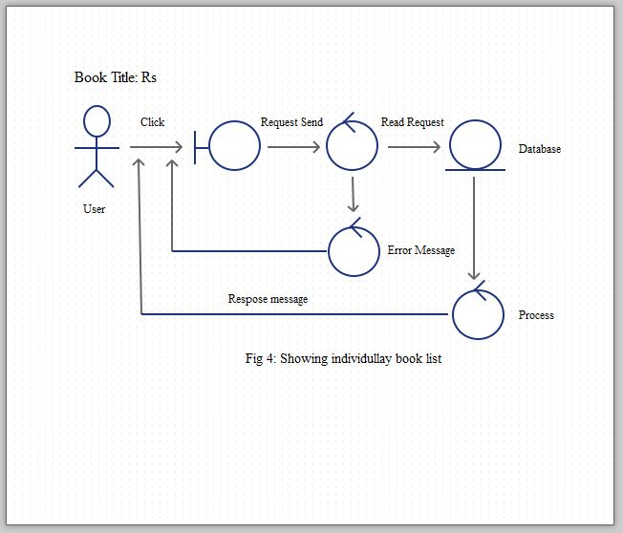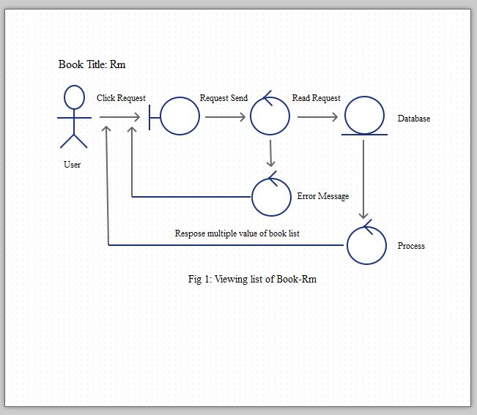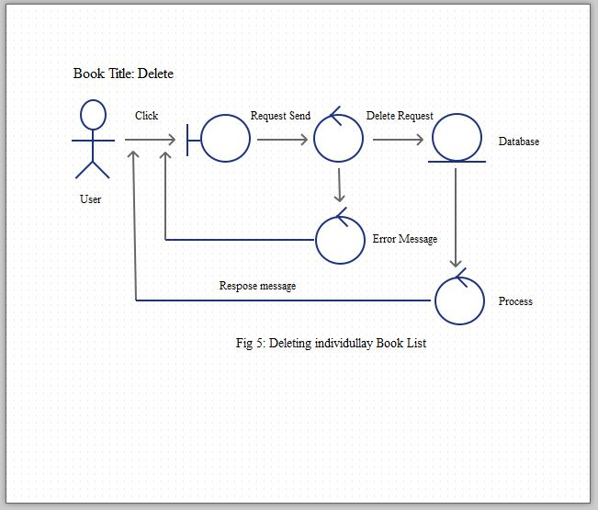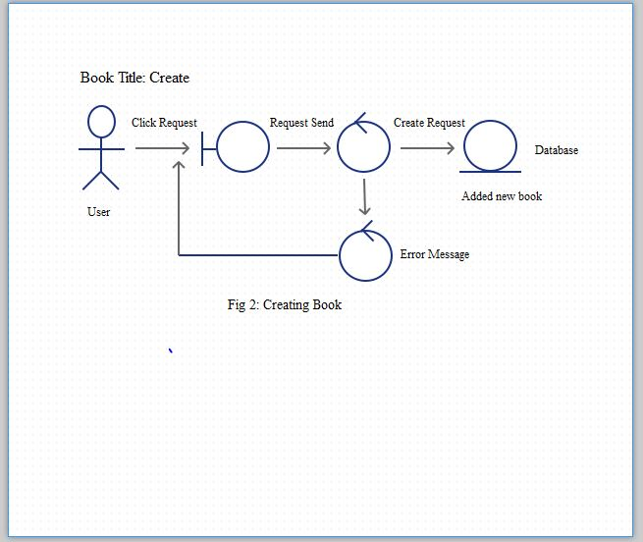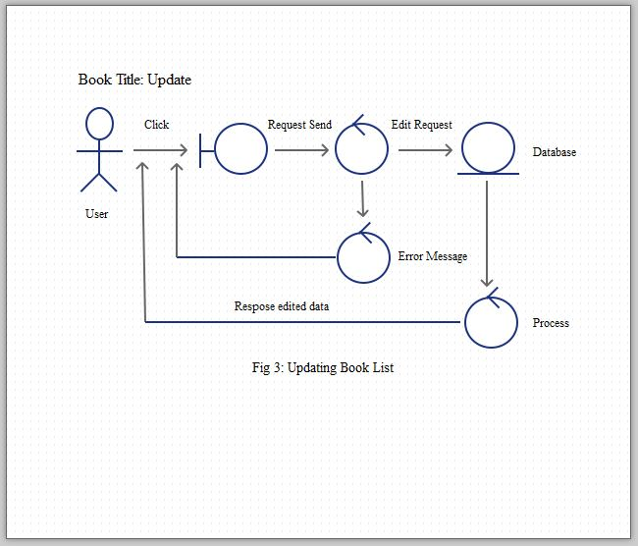

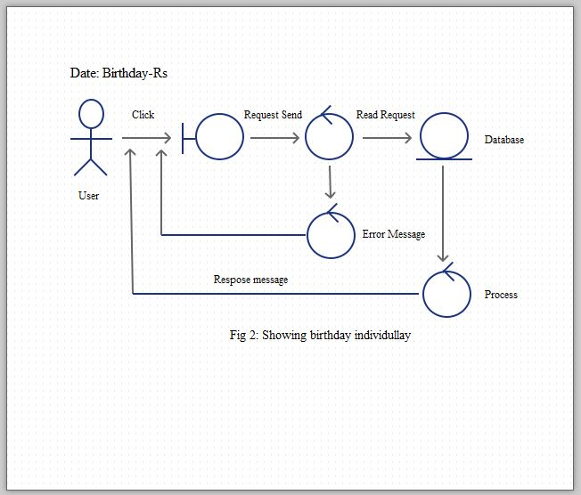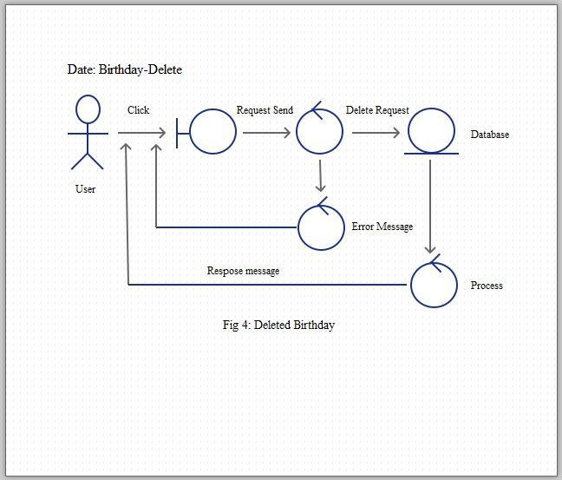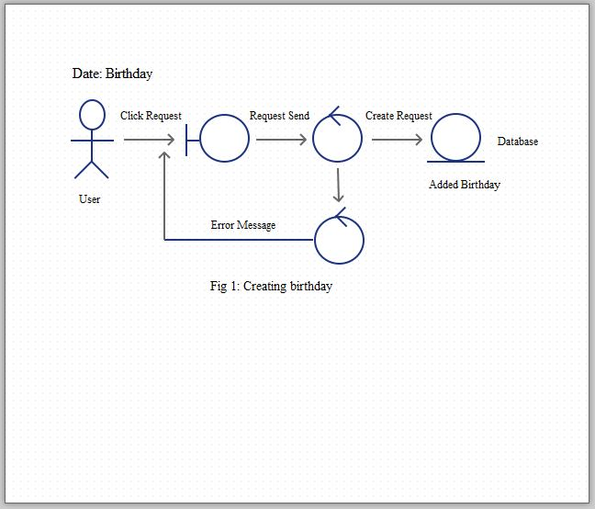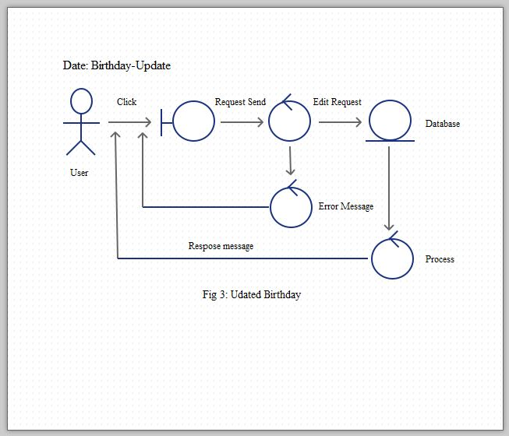

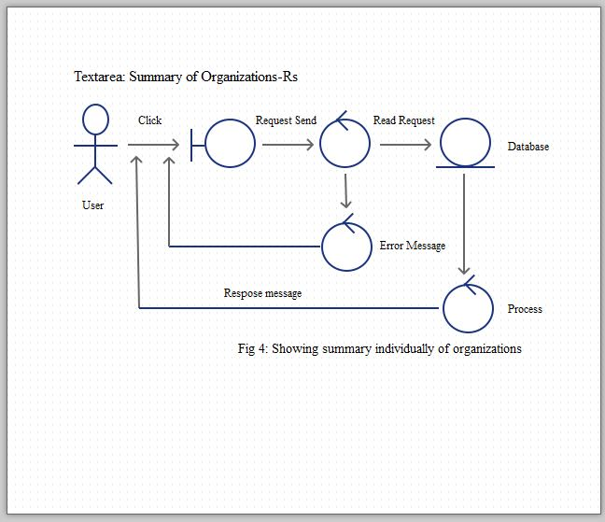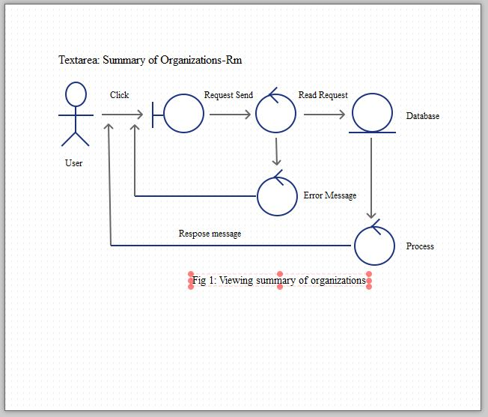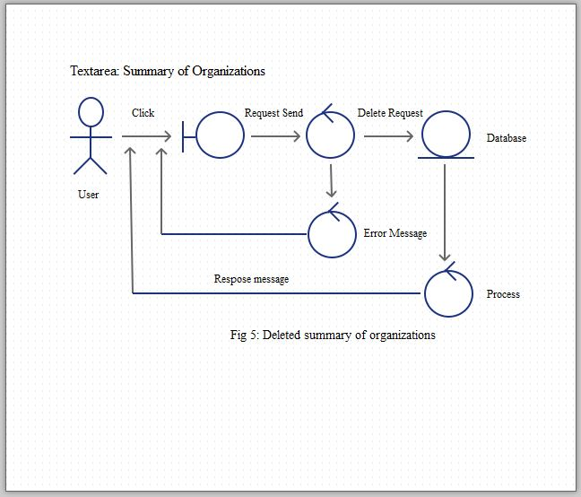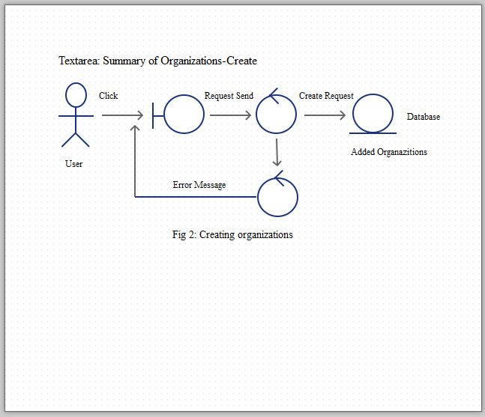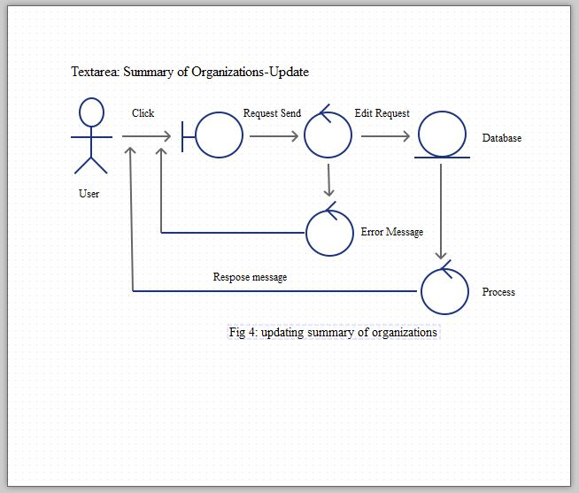

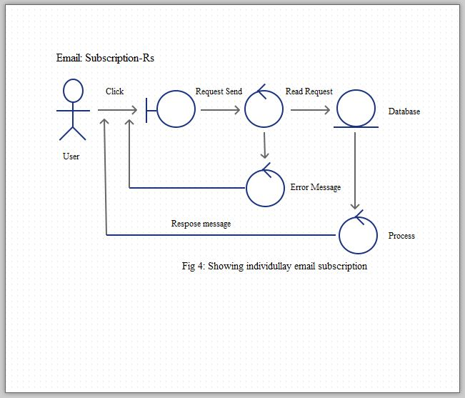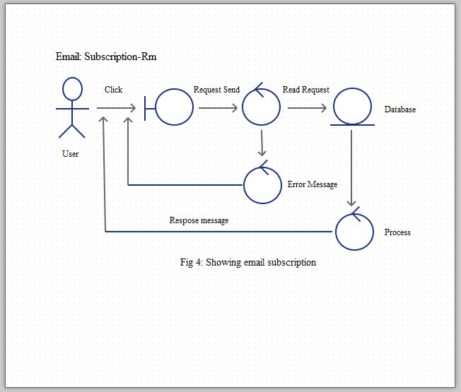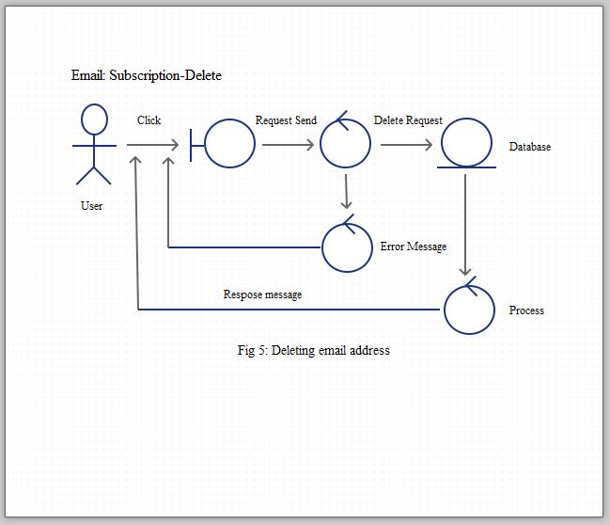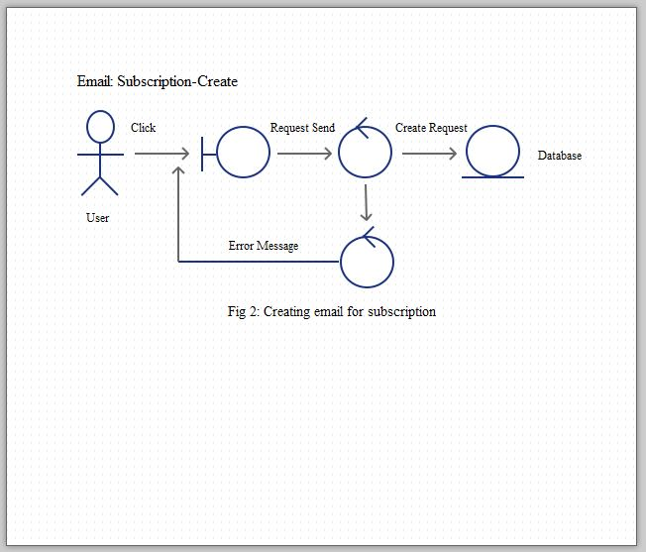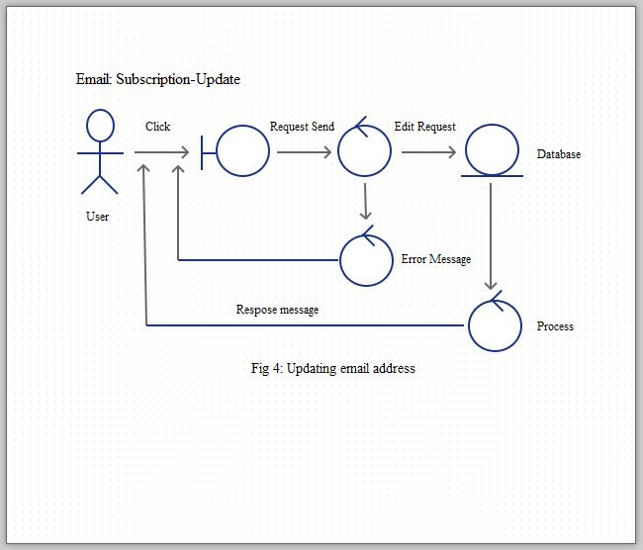

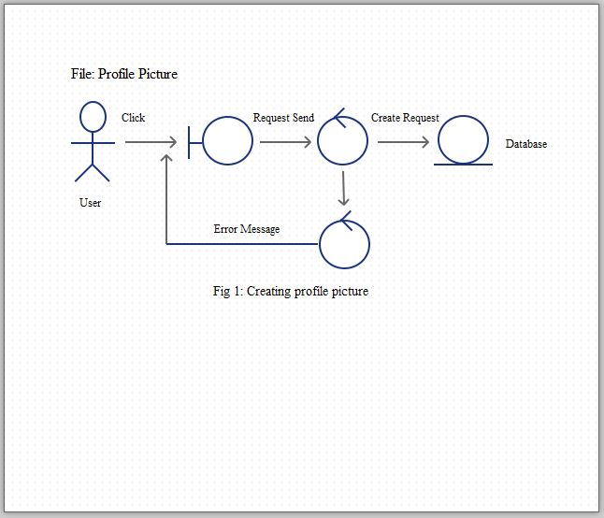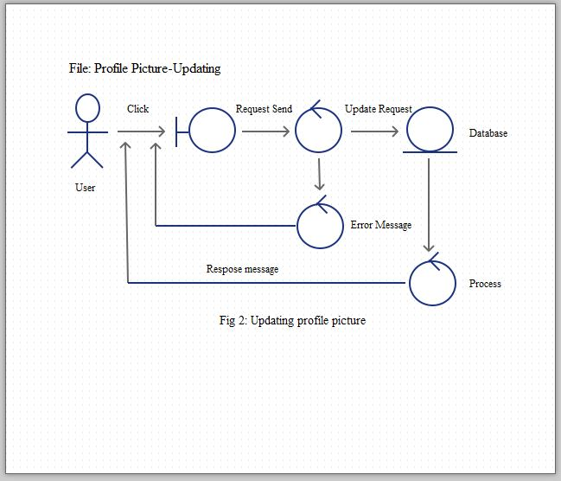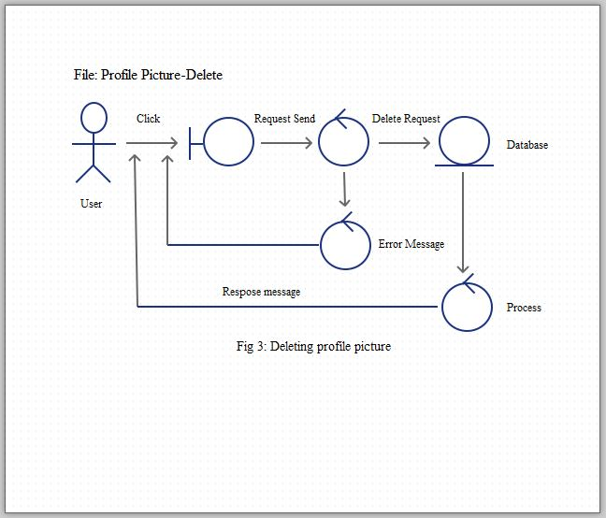

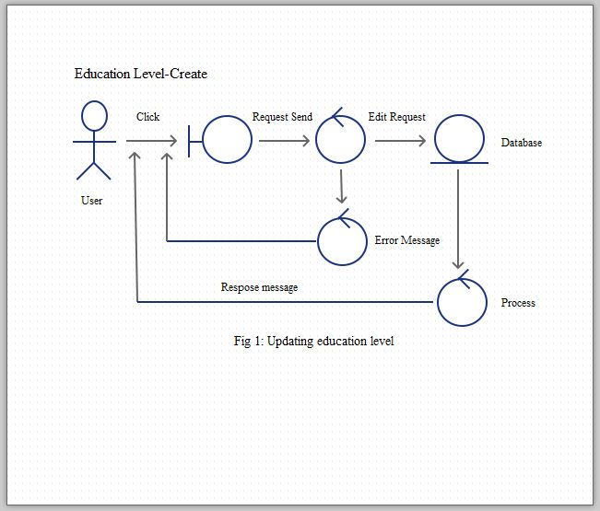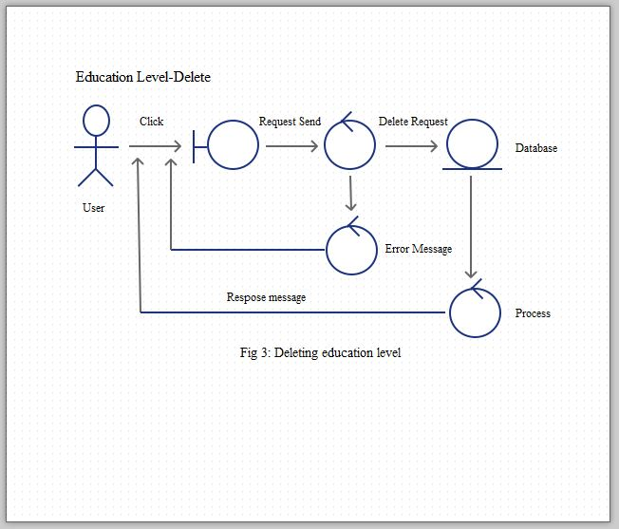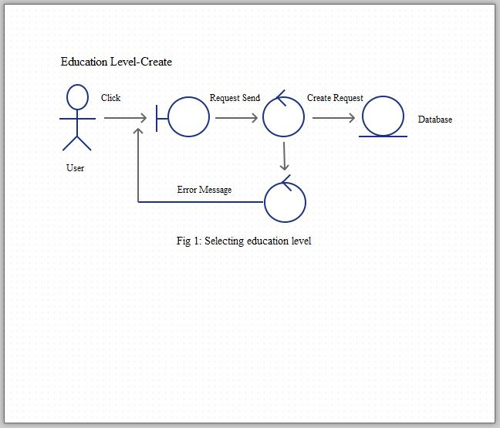

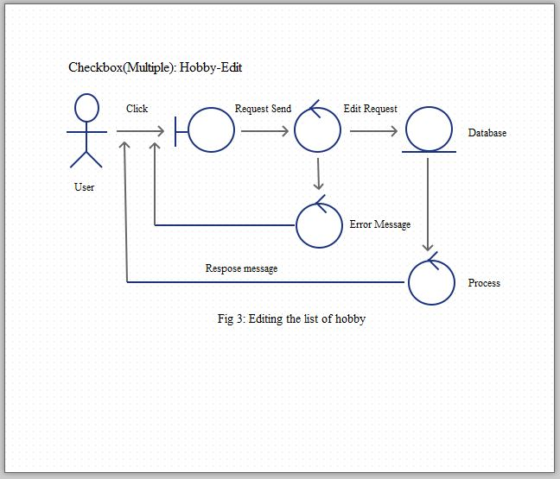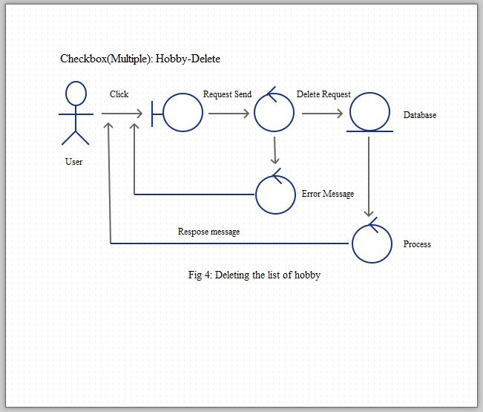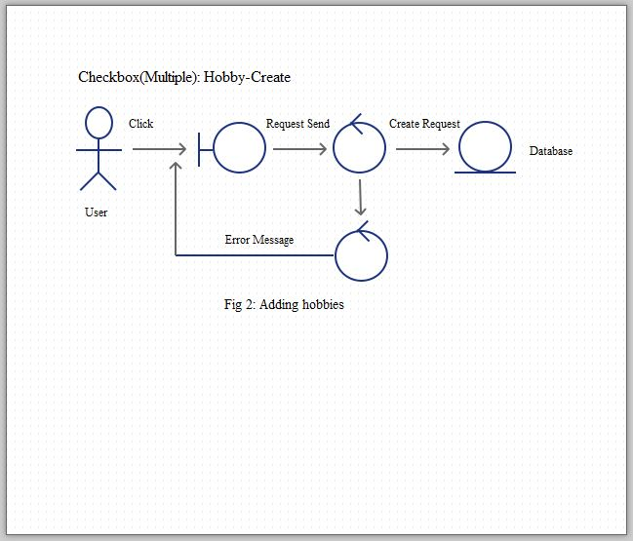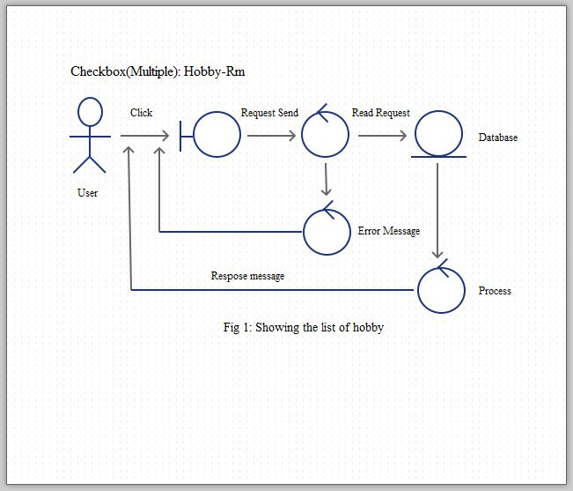

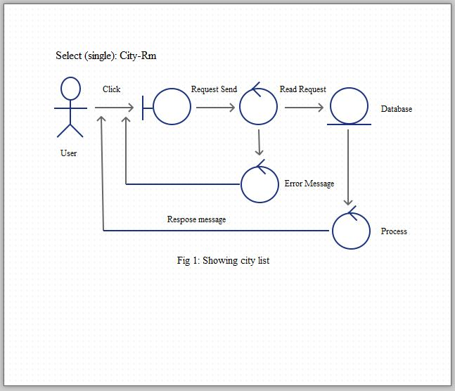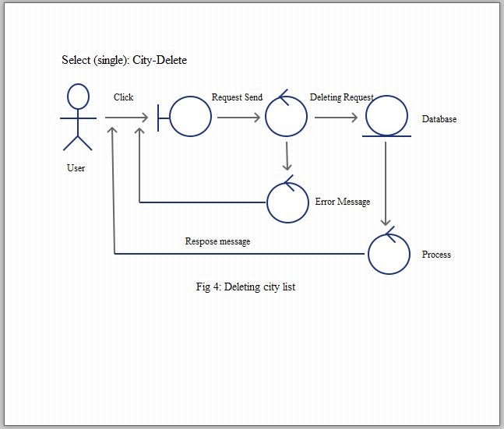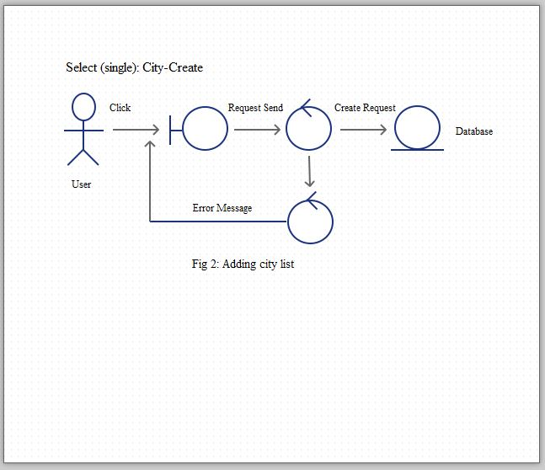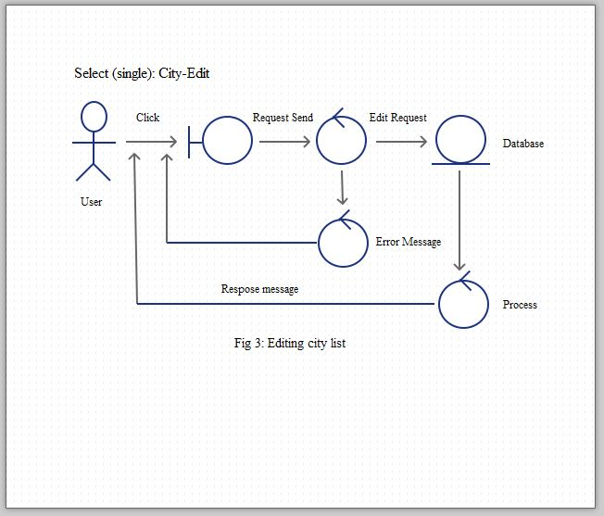

**Class Diagram of User Story:**

|  |
| --- |
| **Book** |
| -book_id  -book_name |
| +book_list()  +book_add()  +book_edit()  +book_view()  +book_delete() |

|  |
| --- |
| **Birthday** |
| -birth_id  -birth_date |
| +birthday_add()  +birthday_edit()  +birthday_viwe()  +birthday_delete() |

|  |
| --- |
| **Organizations Summary** |
| -org_id  -org_name |
| +org_list()  +org_add()  +org_edit()  +org_view()  +org_delete() |

|  |
| --- |
| **Email Subscription** |
| -subscription_id  -email_address |
| +subscription_list()  +subscriber_add()  +subscriber_edit()  +subscriber_view()  +subscriber_delete() |

|  |
| --- |
| **Profile Picture** |
| -pic_id  -pic_name |
| +pic_add()  +pic_edit()  +pic_delete |

|  |
| --- |
| **Education level** |
| -edu_id  -edu_level |
| +edu_level_list()  +edu_level_edit()  +edu_level_edit()  +edu_level_edit() |

|  |
| --- |
| **Terms and Condition** |
| -terms_id  -terms_detail |
| +terms_add()  +terms_edit()  +terms_view() |

|  |
| --- |
| **Hobby** |
| -hobby_id  -hobby_name |
| +hobby_list()  +hobby_add()  +hobby_edit()  +hobby_delete() |

|  |
| --- |
| **City** |
| -city_id  -city_name  -city_detail |
| +city_list()  +city_add()  +city_edit()  +city_delete() |

